# Saturn Power Manager

These notes describe a potential add-on to the balanced mic preamp and power switch board within Saturn. Its objectives are to achieve a foolproof power off and on for the radio, and ensure that the ARM processor is shut down before power is removed. By taking this approach we can reach a state where all radios have the same power management whether they have a front panel or not. We can avoid a potential hazard where a “long press” on the power button will cut off power before a shutdown.

# Rationale

For this to be viable, it needs to be possible to deploy without changes to other board designs; otherwise it becomes a complete new radio project. I’m approaching this for new radios, not as an upgrade for existing ones. That said, there are probably no barriers to implementing an upgrade. The 12 V power switch on the power / preamp board is used; +12V in goes to that board not to the front panels.

* If used with a radio with no front panel: the power switch and LEDs connect to the power management/preamp board as today.
* There are no pins available on the 40 pin connector, so can’t be used with a V1 board unless we did use USB communication to the ARM processor.
* With a V2 front panel: the power switch and LED connect to the power management board via J22. D14 and other components may need to be removed. Switched +12V is wired back to the front panel via J19 to feed the 5V LDO.

A momentary press will be sufficient to turn the radio on. A long press should be used to turn it off, to make sure that the press is deliberate and not accidental contact. Perhaps 2 seconds would be appropriate.

There is minimal information flow to the ARM processor: it simply needs to signal an intent to shut down, and gen back an indication that has happened. The latter can be sensed by 3.3V power monitoring. The former might be a simple GPIO connection, compatible with the current software used to shut down a G2. A future program might be more capable and close down apps such as piHPSDR.

USB interfaces within the current radio are scarce. These in no justification for using a scarce resource for this application.

# Operating Sequence

1. Short press power
   1. Power turns on
   2. Power LED lights
2. Further short press power
   1. Ignored
3. Long press power (I’m thinking 2+ seconds)
   1. Shutdown sequence initiated
   2. Power LED blinks
   3. Microcontroller signals the ARM processor (by CAT message possibly) to tell piHPSDR to save settings
   4. Microcontroller signals the ARM processor to shut down
   5. ARM processor closes apps and powers down
   6. Microcontroller detects ARM power down
   7. Microcontroller shuts off the 12V power
4. A potential upgrade would be to provide a way for external power on request input (e.g. a relay contact) for remote radio operation.
5. A way for the ARM to request shutdown (at the end of configuration for example) may be appropriate.

# Interfaces

1. To the front panel
   1. A button press input, from the pushbutton switch. Contact to ground means button pressed.
   2. One or two LEDs to indicate power state
      1. Indicate power on
      2. Indicate power off
      3. Indicate shutdown has been requested
2. To the ARM processor
   1. A way to signal “shutdown requested”
   2. A way for the ARM to signal “shutdown complete”
   3. A way for the ARM processor itself to request shutdown
3. To an external “startup” input
   1. A relay contact input; a closed contact for say 1s will power on the radio.

There is no significant further information flow required. There is only one bit of information to be passed to the ARM (shutdown requested) and one but from the ARM (shutdown is complete).

# Potential Solution

A simple microcontroller added to the power management/preamp board. This could connect to two GPIO on the ARM, to the front panel and to the power switch. This could be as simple as an 8 or 18 pin microcontroller with no USB or serial interface: ie a very low cost component.

An ATTINY412 (8 pin) device costs around £0.35, but they are only available as SOIC footprint.

## User Operation Sequence

* Primarily the power switch is controlled by the user front panel button:
  + The initial press of the power button turns the radio on
  + A 2s “long press” initiates shutdown (this is to avoid an accidental press when operating a nearby control)
  + The LED blinks at this point, as indication it is shutting down
  + Once the button is released, it signals the ARM processor to shut down
    - Logic 0 open drain output to a GPIO pin
  + After the ARM shuts down, it waits 10s then turns off the 13.6V power.
    - Detected by 3.3V power off (for Radxa) or gpio-shutdown pin (raspberry pi CM4)
* There is also a mechanism for the ARM to request power off.
  + This would be used with the Radxa CM5 after configuration; and the Radxa can switch 3.3V off when it shuts down.
  + The power manager activates the input after 30s (to avoid startup glitches)
  + The ARM asserts the input to 0 to request power off
  + The power manager detects 2 consecutive samples (10ms spacing) at logic 0
  + The power manager blinks the LED
  + Power manager waits for ARM active (3.3V supply) to be deasserted
  + Power manager waits 10s then switches off 13.6V power.

## State Behaviour

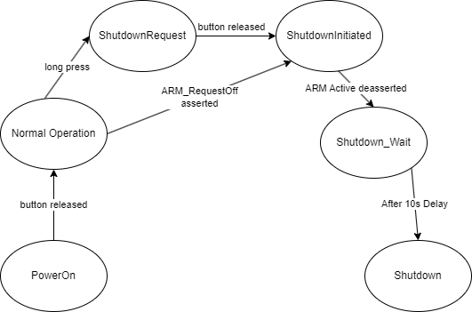

A simple set of states will be advanced by button presses and reaction from the ARM.

|  |  |  |
| --- | --- | --- |
| **State** | **Function** | **Signals Driven** |
| Power_On | Power up into this state. Scan pushbutton and await a debounced released | 12V_ON  LED solid red |
| Normal_Operation | The radio will spend the whole operating session in the state. Await a long press | 12V_ON  LED solid red |
| Shutdown_Request | Triggered by a long press. Take no action yet; await the button release | 12V_ON  LED blinking red |
| Shutdown_Initiated | Signal the ARM to shut down. Await removal of ARM 3.3V | 12V_ON  LED blinking red  Assert ARM_shutdown |
| Shutdown_Wait | Wait 10s for operating system fully to close down | 12V_ON  LED blinking red  Assert ARM_shutdown |
| Shutdown | Power off the 12v switch. | Deassert 12V_on  LED off |

## Interface pins

|  |  |  |  |  |  |
| --- | --- | --- | --- | --- | --- |
| **Signal** | **Pkg Pin** | **I/O #** | **Direction** | **Level** | **Function** |
| Pwr_On | 7 | 4 | Output | 0=off; 1=on | Holds the 12v power switch on |
| LED | 5 | 3 | Output | 0=off; 1=LED lit | Drives power LED directly |
| SW_In | 3 | 1 | Input | 0=sw pressed. Uses  internal pullup | Indicates user switch pressed |
| ARM_Shutdown | 4 | 2 | Output (open collector) | 1=on (or o/c); 0=shutdown | Indicates ARM to shut itself down  (Open collector achieved by only enabling as output when powering off) |
| ARM_Active | 2 | 0 | Input | 1=active;  0 = shut down | Indicates whether ARM has shut down. Taken from 3.3V power supply (if gated) or GPIO driven by the gpio-shutdown |
| ARM_RequestOff | 6 | 5 | Input (with pullup)  (Uses UPDI pin) | 1= normal operation;  0=request shutdown | Allows ARM to request power off. |

The Atmel processor will need to operate at 3.3V. ARM_Active is a 3.3V supply rail; the ARM_shutdown input to the ARM processor could be 1.8V or 3.3V. Ideally that pin would have a pullup, and we would drive an open collector output. But if both pi5 and Radxa CM5 can provide a 3.3V level signal, we can use normal totem pole output.

## Simplified Schematic

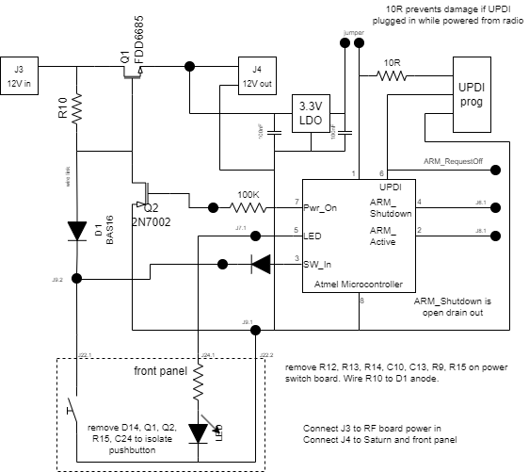

This amounts to adding an LDO and 8 pin microcontroller to the power switch/preamp board; connectors to LED and pushbutton switch on the front panel. Some of the existing components will need to be removed both on the power switch/preamp and G2V2 front panel.

The LDO can also be used as the bias supply for the preamp.

## PCB modifications

|  |  |
| --- | --- |
| Front panel | Remove D14, Q1, Q2, R15, R24 to isolate the switch. Connect switched +13.6V supply to J19. |
| Power switch & Preamp | Connect power to J3. Connect J4 to Saturn J44 and front panel J19. (Be aware that at least my prototype power switch board has the polarity of J3, J4 reversed from that on Saturn and the front panel).  Remove R12, R13, R14, C9, C10, C13, C14, R9 & R15; add prototype adapter with microcontroller and LDO.  Wire R10 to D1 anode. |

## Remote Power On

There is interest in remotely operating the G2. Remote power on/off will need externally controlled power (to switch on/off the 13.6V PSU that supplies the G2) and a way to turn the radio itself on. A relay contact wired across the pushbutton switch would allow it to be turned on remotely; an extra connector to bring this out is all that would be needed. Timing is no longer critical with the microcontroller modification.

# Programming

Programming for all modern Atmel devices is via UPDI. You can convert an Arduino nano into an UPDI programmer – see this site: <https://daumemo.com/diy-updi-usb-programmer-which-can-be-made-with-cheap-hardware/>

Don’t add the 10uF capacitor until after programming the firmware.

## Arduino Programming

It is possible to program an ATTINY device using the Arduino environment by installing the Megatiny core

Add this line to board manager URL list in file-> preferences:

<http://drazzy.com/package_drazzy.com_index.json>

Then select **tools->board -> boards manager**

Find **megaTinyCore** by Spence Konde & install

Install timer library for this core:

* open library manager
* Search for Attiny_TimerInterrupt by Khoi Hoang
* Select **Install**

Select **Tools->Board->megaTinyCore->ATtiny412/402/212/203**

Select **Tools->Port->(com port for programmer)**

Varius settings can be made in the section below “get board info” on the Arduino Tools menu: For this project everything has been left as defaults other than programmer: select “jtag2updi”

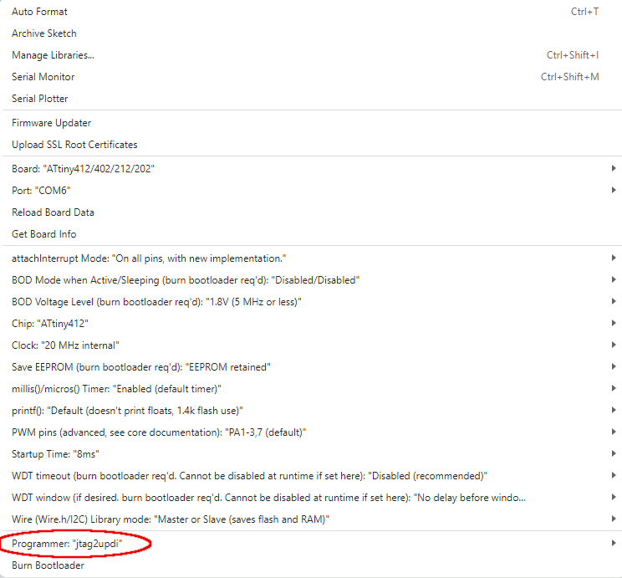

This is the pin naming: pin labels in orange give the Arduino digital pin numbers. A simple “blink” sketch with the LED on pin 5 (numbered 3 in Arduino code) works.

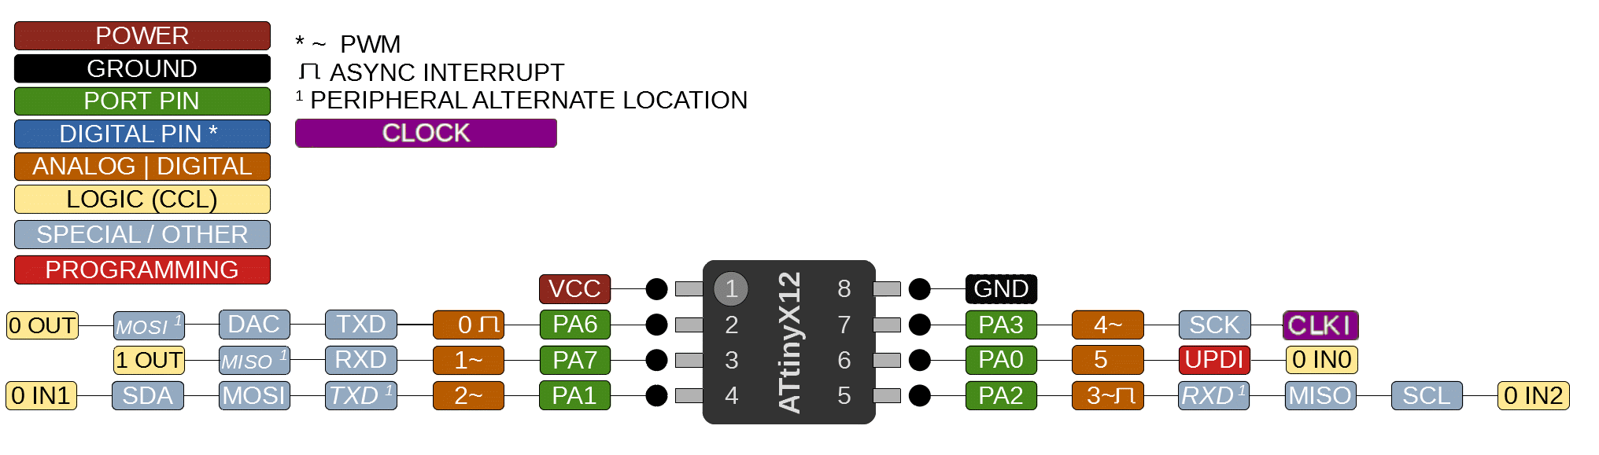

The UPDI pin CAN be used as a normal input as well as being used for programming.

# Prototype

A simple prototype might be a Veroboard add-on to the existing power switch board.

Provision needs to be made for power to come from the 3.3V LDO (normal operation) or the 5V UPDI (for programming). When the latter, it will need to be disconnected from the ARM processor as the microcontroller will be driving 5V outputs. To mitigate this, the ARM_Shutdown output has been made an open collector output

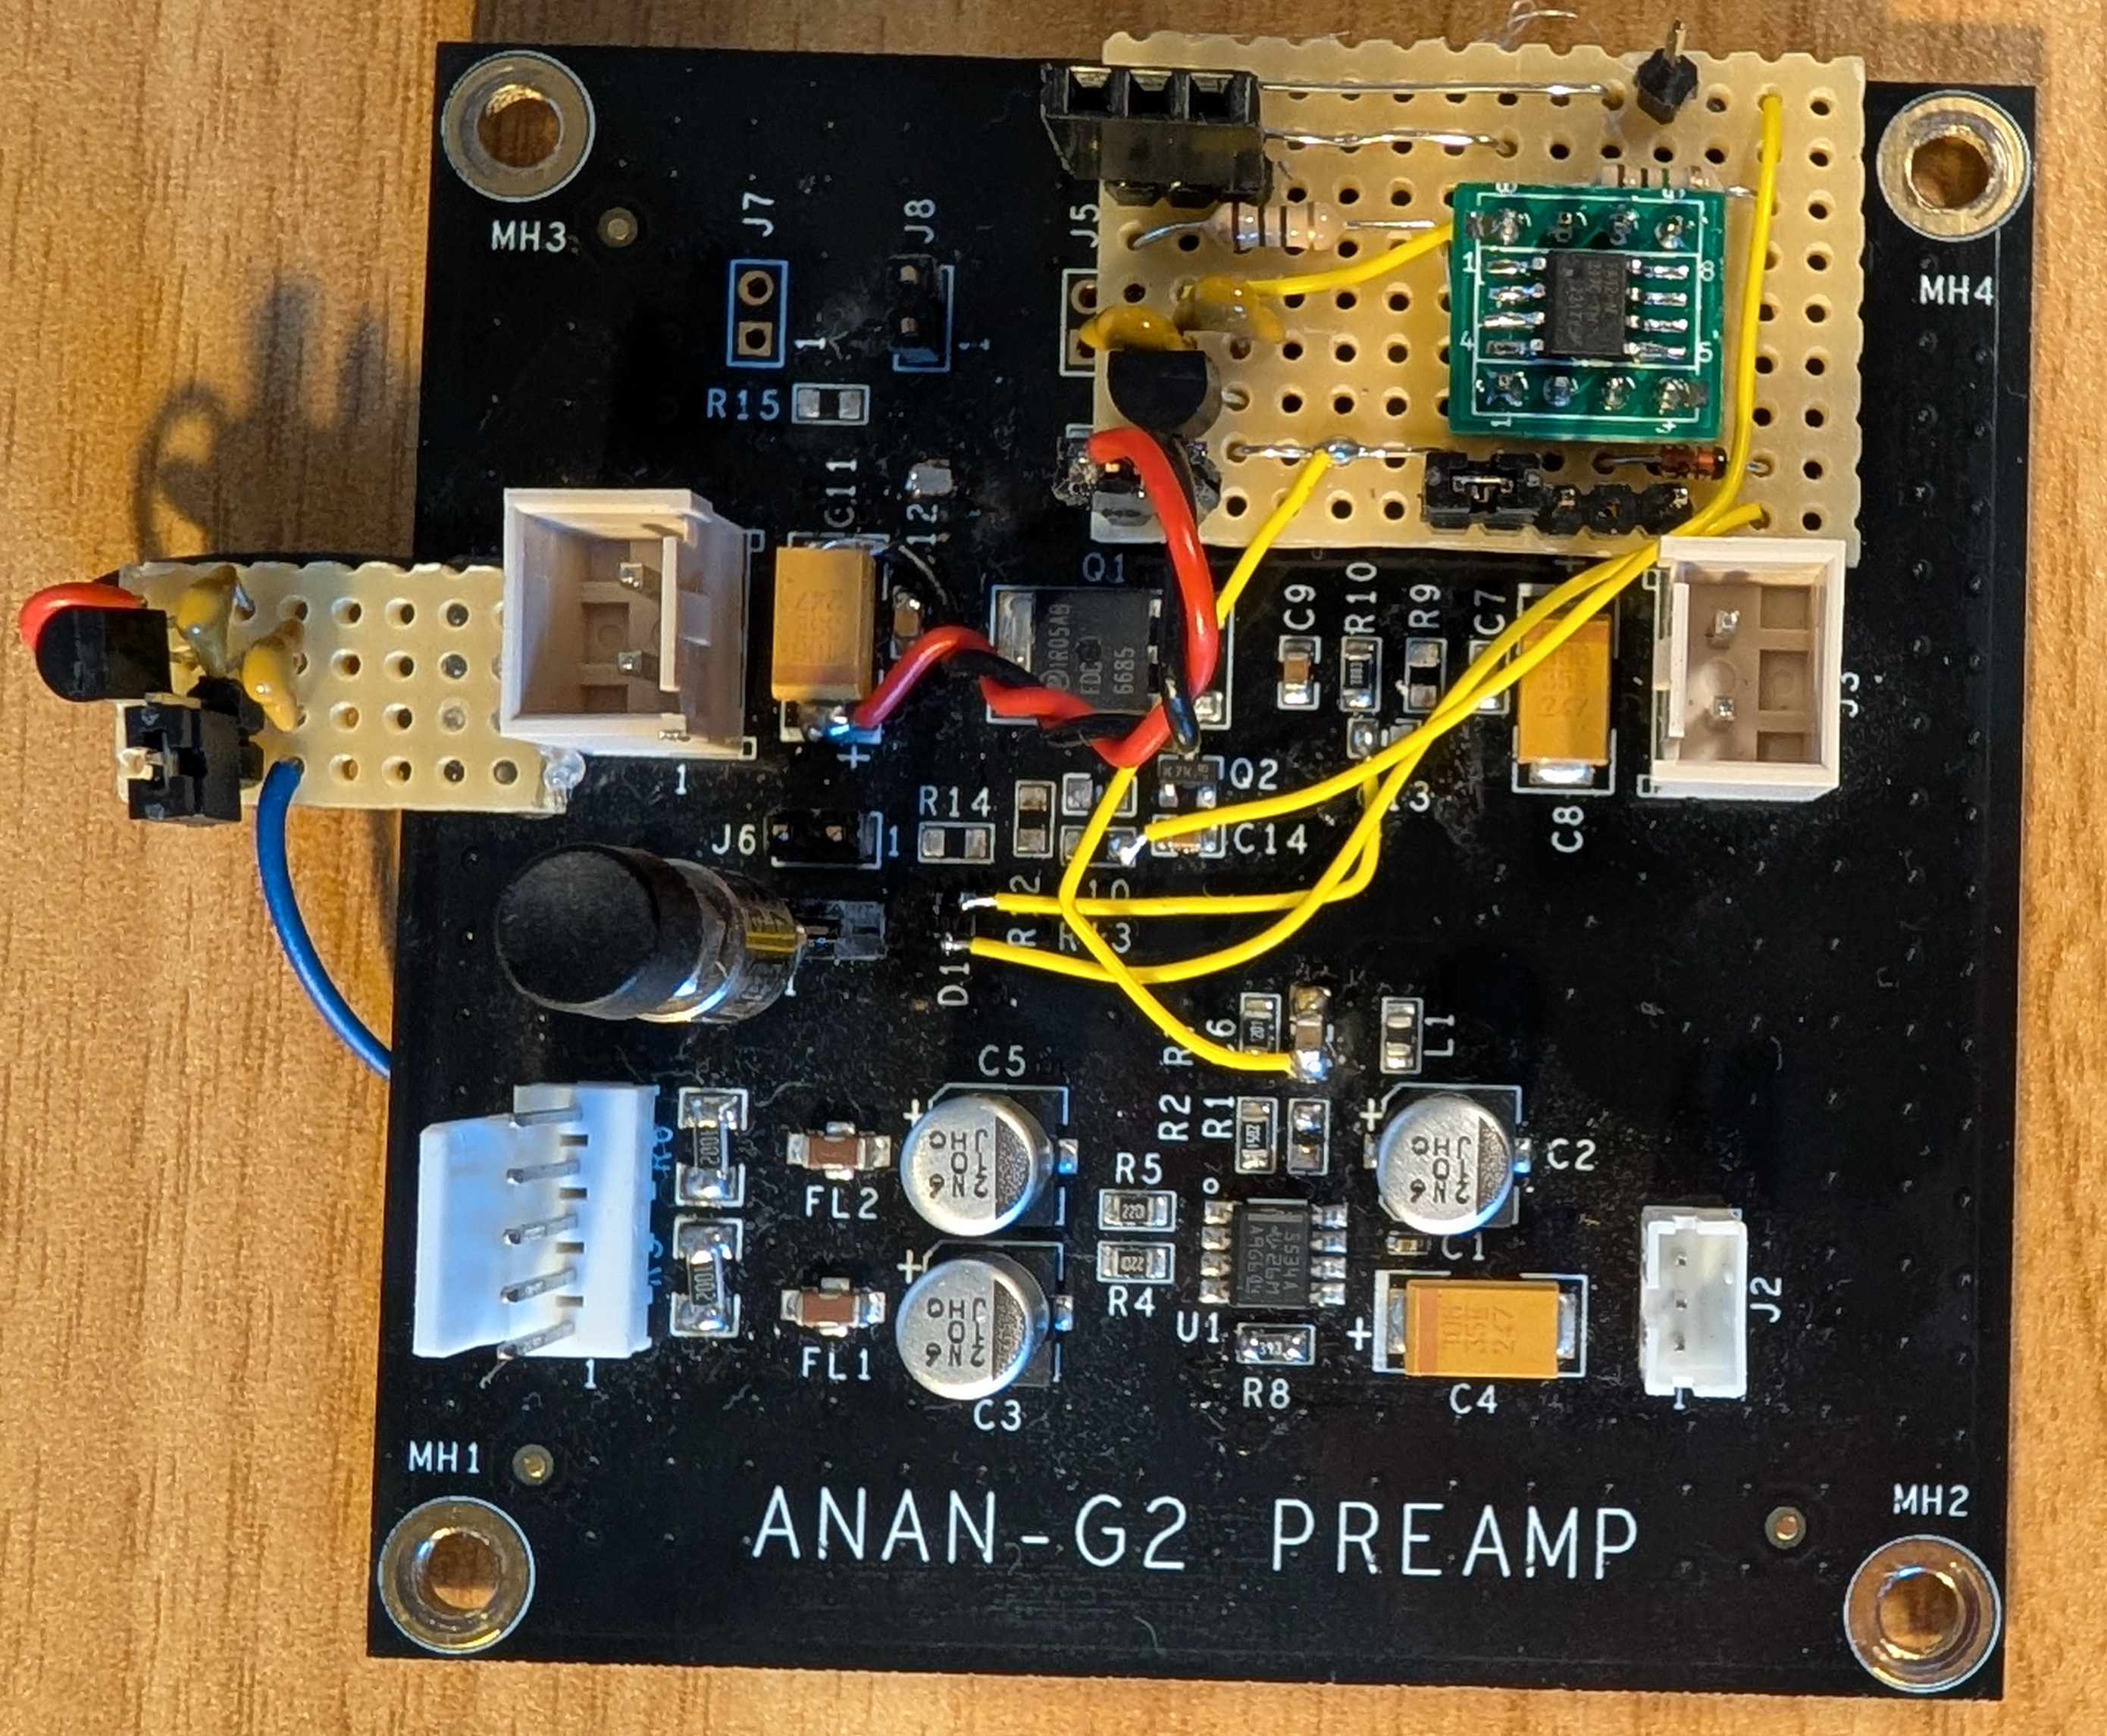

# Raspberry Pi Settings

## Pre bookworm

The /boot/config.txt file needs a device tree overlay:

#G2V2 power shutdown. Set pin 26=shutdown input, 18 = LED output

dtoverlay=gpio-shutdown,gpio_pin=26

gpio=18=op,dh

## Post Bookworm

The gpio-shutdown overlay method no longer works. Instead, a simple script needs to be autostarted.

|  |  |
| --- | --- |
| Script: | In file github/Saturn/scripts/shutdown-waiter.sh:  **#**  **# script to wait for a shutdown input**  **# put GPIO26 (pin 37) into pullup mode**  **# The first read will be before the pullup is activated**  **# so wait for a delay before scanning proper.**  **#**  **sleep 20**  **gpioget --bias=pull-up gpiochip0 26**  **pinvalue=1**  **sleep 2**  **echo "waiting for shutdown to be triggered..."**  **while [ $pinvalue -eq 1 ]**  **do**  **# poll input every second, and wait for logic zero**  **pinvalue=$(gpioget --bias=pull-up gpiochip0 26)**  **sleep 1**  **done**  **echo "shutdown request detected"**  **shutdown 0** |
| Auto running the script: | Add a file “g2-shutdown.desktop” in folder ~/.config/autostart. Make the file executable by anybody.  The file should contain:  **[Desktop Entry]**  **Type=Application**  **Exec=/home/pi/github/Saturn/scripts/shutdown-waiter.sh**  (There is a folder ~/github/Saturn/autostart files that contains this file plus ones for p2app, piHPSDR; copy the required files to ~/.config/autostart) |

# Issues

There is an issue with the first prototype whereby the power sometimes glitches back on; notably when the temperature is warm. This is after removing further capacitors C9, C14.

Speculated cause: the power does not reduce monotonically and the processor enters “grey” power state and restarts. If it restarts; it immediately asserts the output Pwr_on to apply radio power.

Suggested solution:

When initialising: Changed code to only assert Pwr_On after detected pushbutton input is presed